**Lab Assignment – 5**

***Cloud Databases - GCP-SQL***

***19CSE445 – Cloud Computing***

**11. HTML Webpage:**

* **Localhost:**

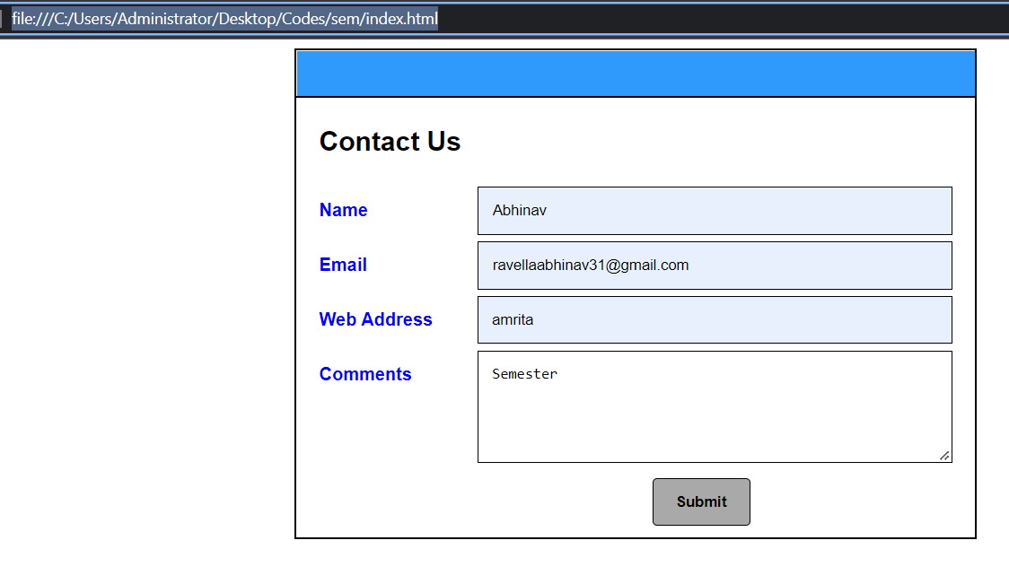

* **Access through VM Instance:**

**Link:** [**http://35.232.17.123:8080/**](http://35.232.17.123:8080/)

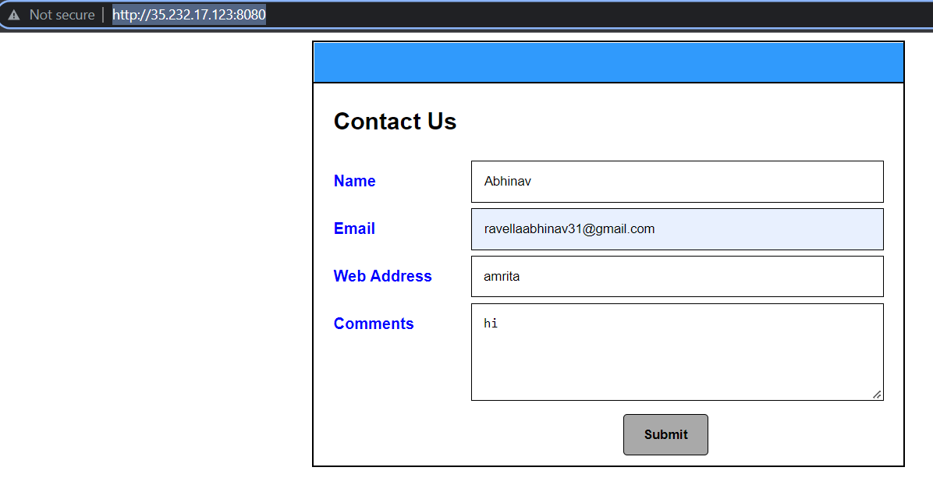

**12. MySQL Instance:**

* **Database & Table Creation:**

create database semester;

use semester;

CREATE TABLE ContactUs(

fname VARCHAR(40),

email varchar(40) PRIMARY KEY,

link varchar(40),

subject varchar(100)

);

select * from ContactUs;

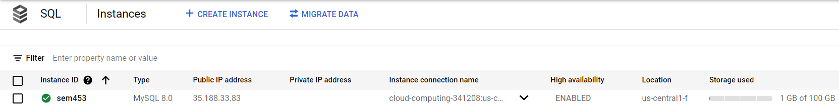

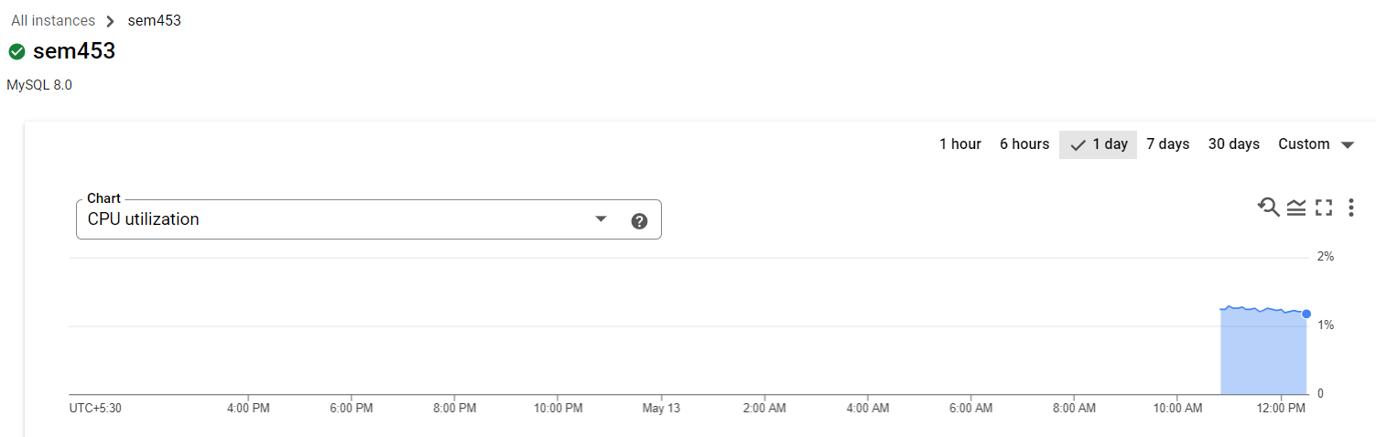

**Workbench Table Insertion using code:**

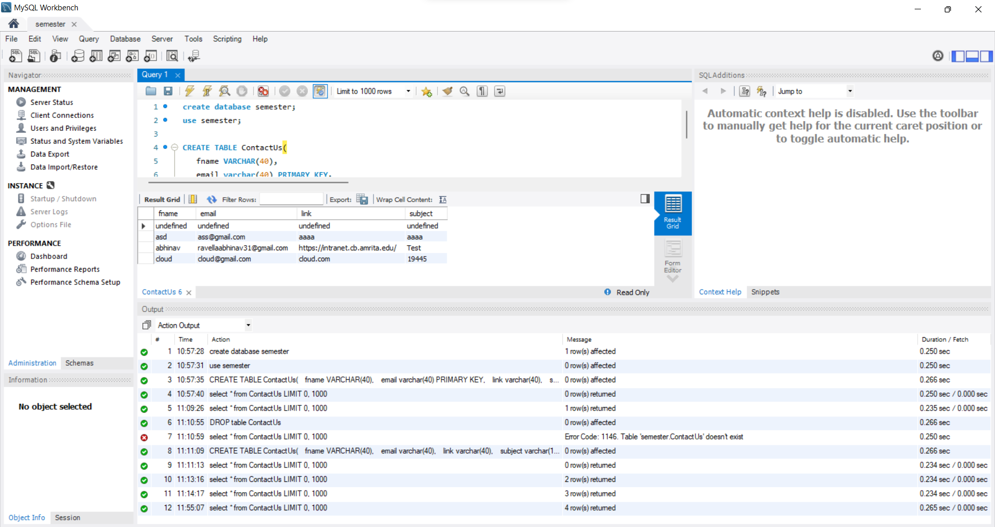

**13. Function Creation:**



**Function-1:**

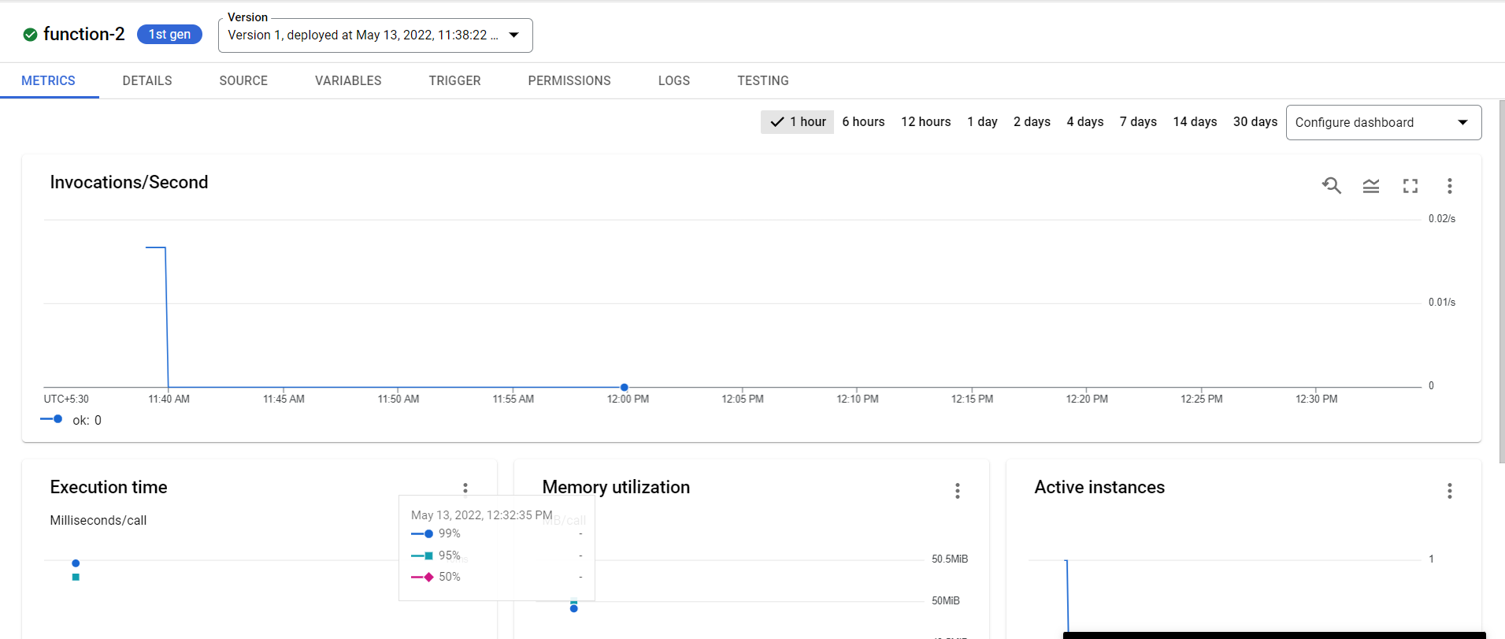

**Function-2:**

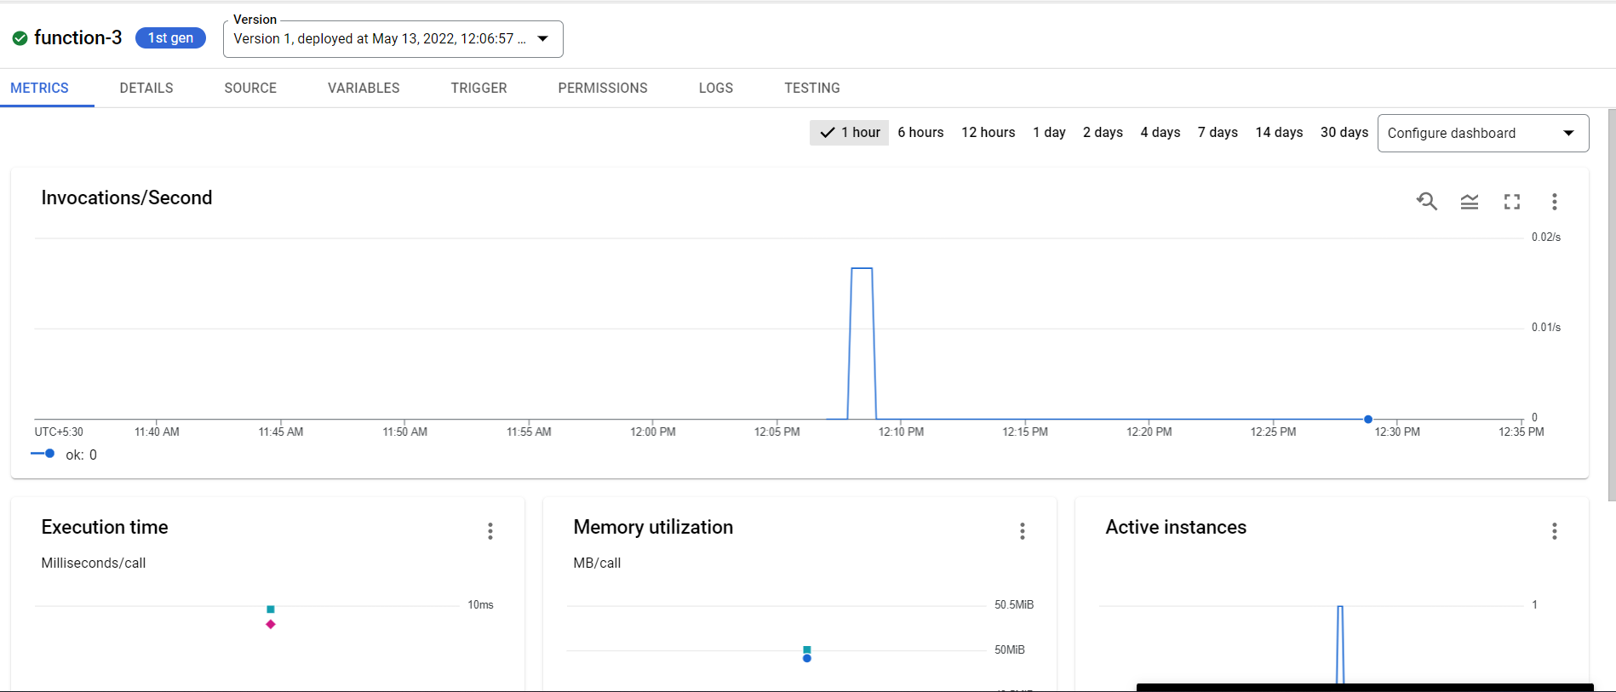

**14. Webpage Validation:**

* **If email not filled:**

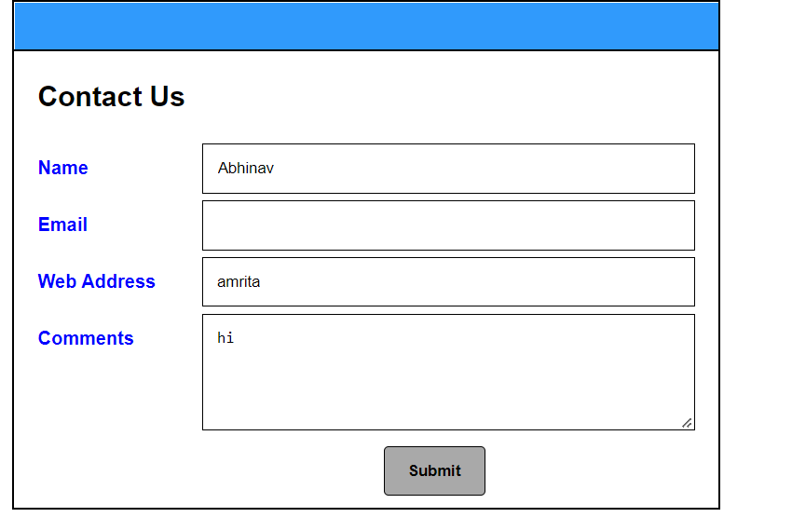

**Errors:**

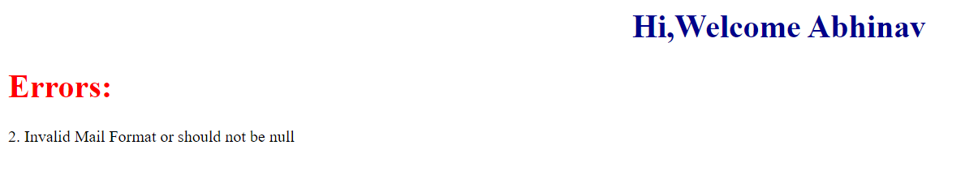

**15. If no errors:**

* **Then nothing will be printed under errors:**
* **Text file is not done**

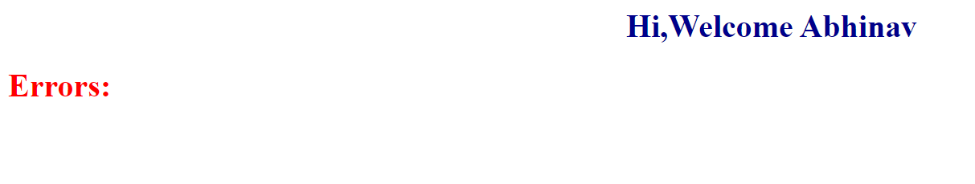

**Codes:**

**Servers and client files in the folder**

var http = require("http");

var path = require("path");

var fs = require('fs');

http.createServer(function (req, res) {

    fs.readFile(__dirname + '/index.html', function (err,data) {

        if (err) {

            res.writeHead(404);

            res.end(JSON.stringify(err));

            return;

        }

        res.writeHead(200);

        res.end(data);

    });

}).listen(8080);

// Console will print the message

console.log('Server running at 8080');